Statistics: Construction

The following charts and graphs provide a high-level view of statistics in the construction sector from 2013 to 2017. You can use these resources to quickly see a comparison of injury rates and serious injuries, and to get information on the top injury types in your industry.

* **Injury rate**
* **Serious injury claims**
* **Claim characteristics**
* **More detailed data**

Injury rate

The following charts illustrate how many claims and serious injury claims an industry has for every 100 workers, and the change in this rate over the most recent five-year period. Industries with a higher rate than other industries are considered more risky, while industries with a lower rate are considered less risky. The ultimate target is to have an injury rate of zero.

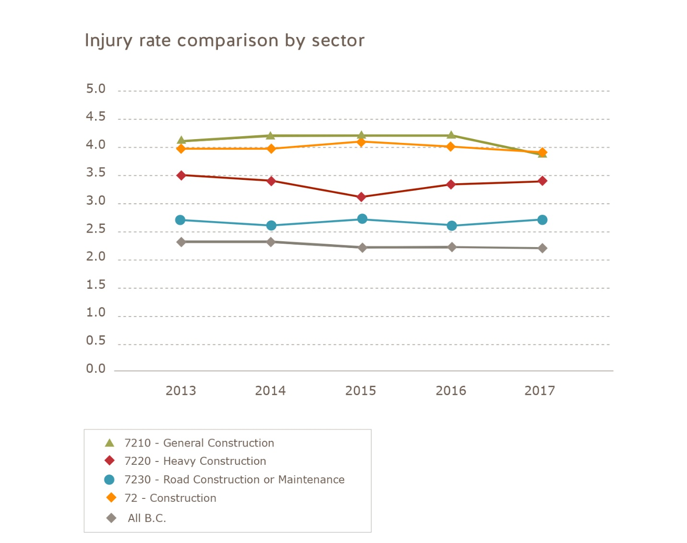

Serious injury claims

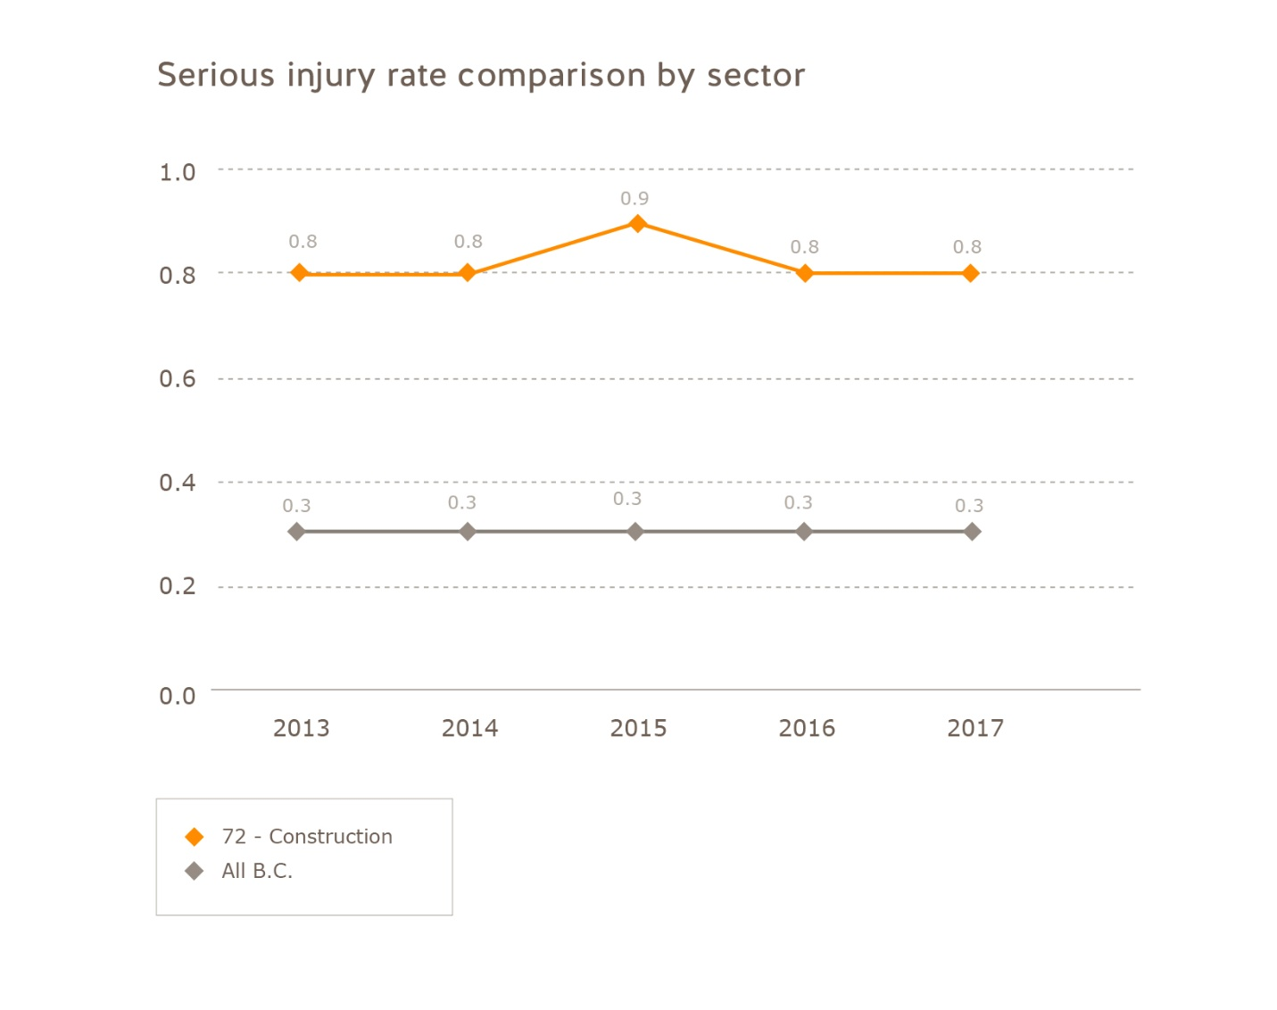

For more on serious injuries, see the [Serious Injuries Dashboard](https://public.tableau.com/profile/worksafebc#!/vizhome/SeriousInjuryDashboard/SeriousInjuriesatWork).

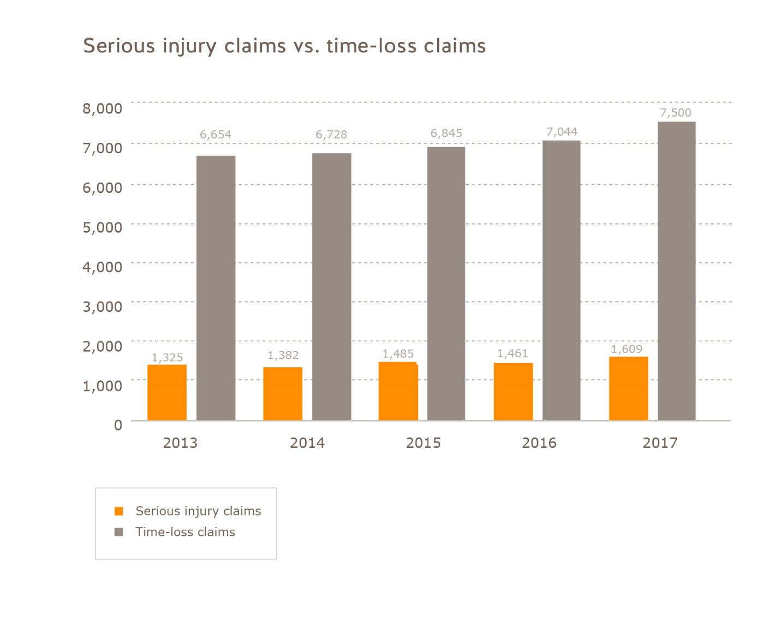

Claim characteristics

**Incident type**

The following charts illustrate the leading causes of injuries in the industry over a five-year period. Incident types that represent a high percentage of claims in an industry are potential focus areas for health and safety programs.

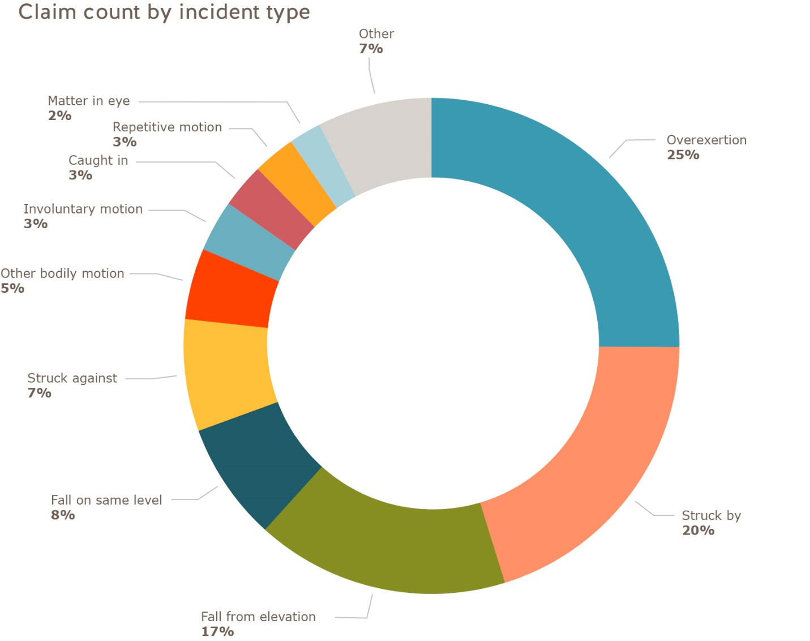

**Sources of injury**

The following charts illustrate the leading sources of injury over a five-year period. Sources of injuries contributing to a high percentage of claims or claim costs paid in an industry are potential focus areas for health and safety.

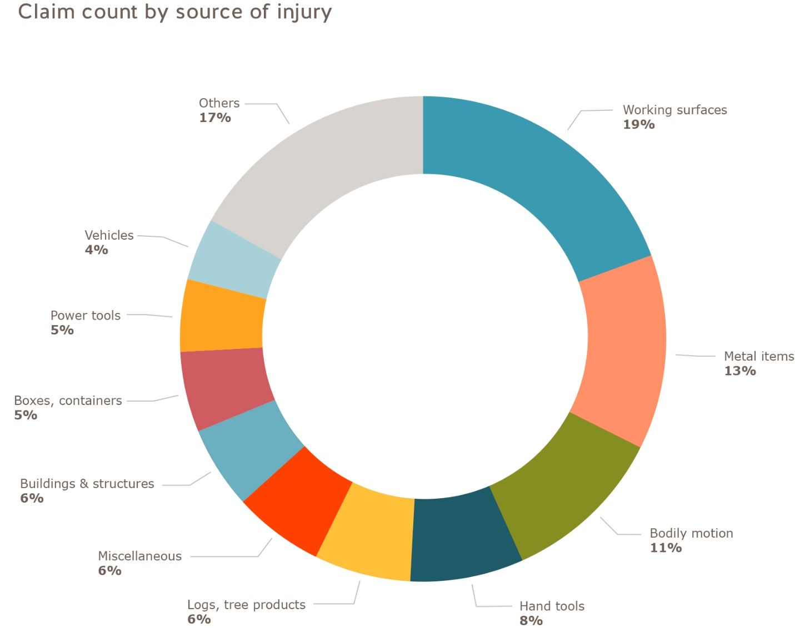

More detailed data

The [Industry Safety Information Centre](https://online.worksafebc.com/anonymous/wcb.ISR.web/Default.aspx?_ga=1.28525948.1723231053.1444778843) (ISIC) allows you to get detailed data for any industry or classification unit such as injury rates, claim costs, injury characteristics, and assessment rates. You can use the ISIC application to look at information for any industry and industry subsector in B.C. by selecting the appropriate classification units from its drop-down menus on the right-hand side.